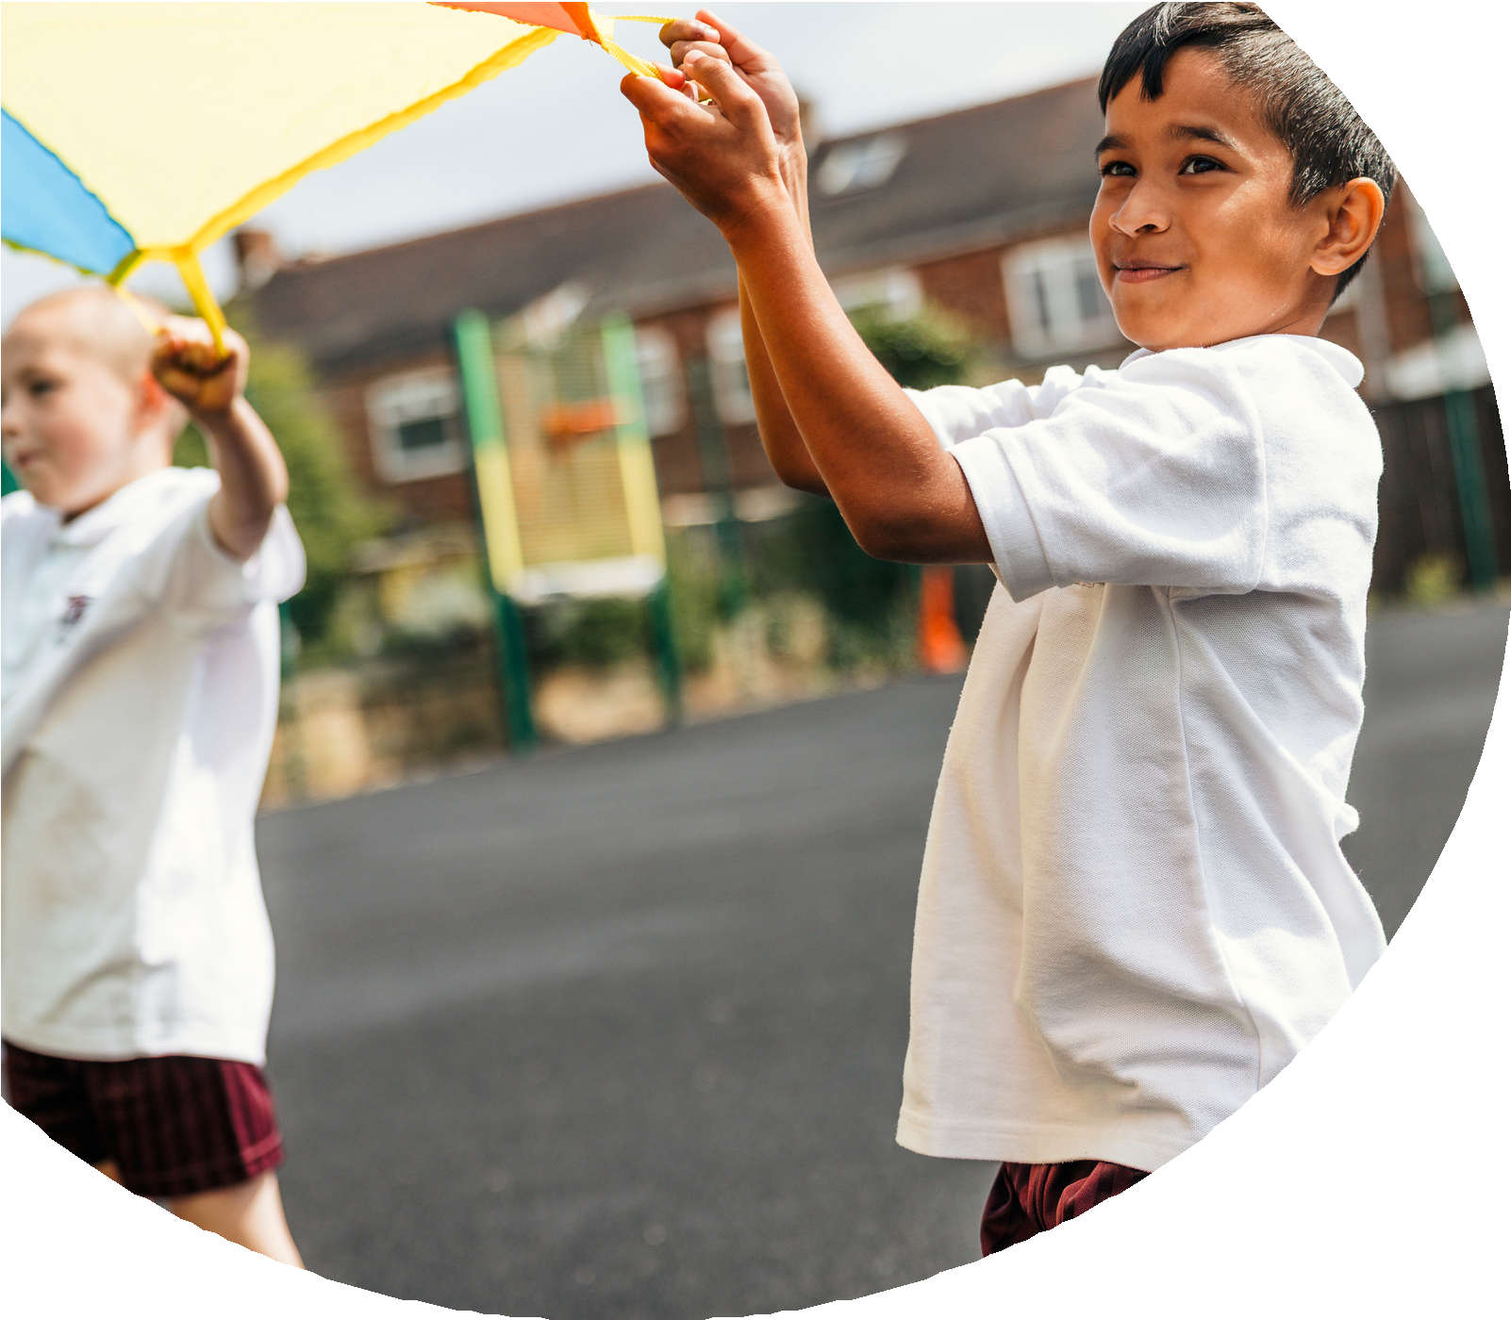
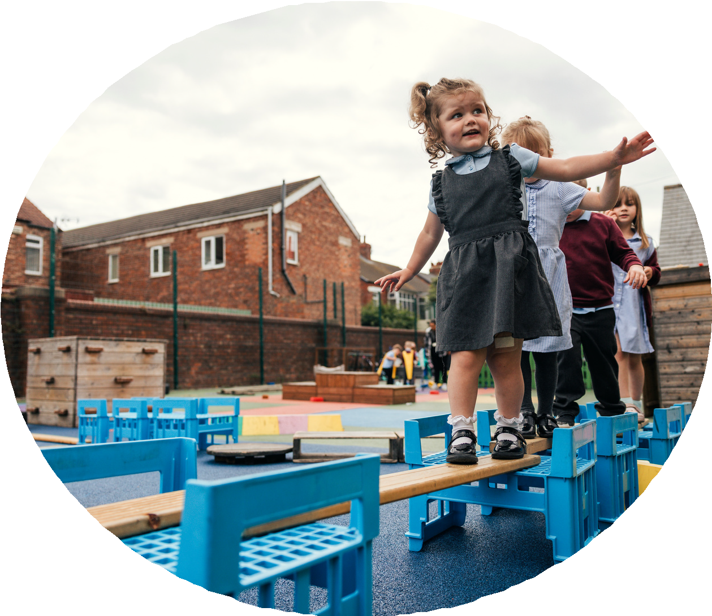

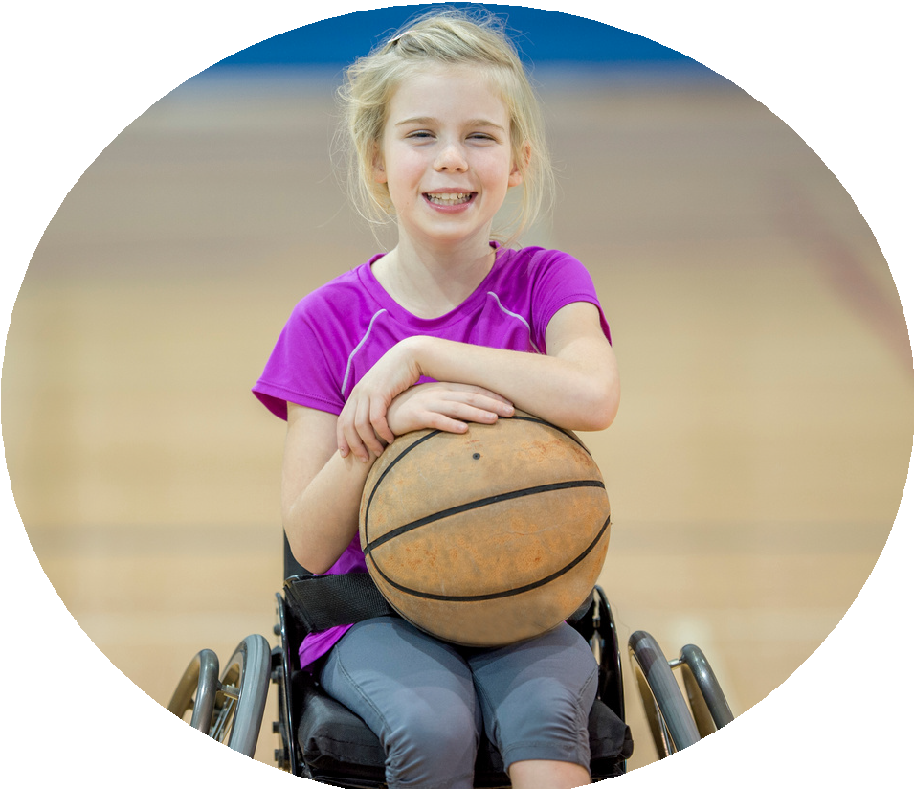



PE and sport premium monitoring and tracking form 2025/2026

Commissioned by

Created by


PE and sport premium monitoring and tracking form
- It is intended that this template should be used as preparation for the completion of the statutory DfE PE and sport premium digital expenditure reporting return. You can upload data (including swimming) from this template onto this platform once it becomes accessible.
- The template is a working document that you can amend and update during the year.
- Before you decide how you are going to use the funding for this academic year you should reflect and evaluate the impact of your use of you PE and sport premium funding in 2024/25.
- You should use your evaluation of last year’s funding to help you decide what to do this academic year, how you will do it, and what impact you expect it to have.
- All spending of the funding must conform with the terms outlined in the conditions of grant
- The summative digital expenditure reporting from June 2026 will continue to include swimming and water safety information. PE and sport premium funding can be used to provide top-up lessons, where necessary, to ensure pupils meet national curriculum swimming requirements
- To ensure funding is used effectively and based on your school’s needs; guidance and examples of best practice across schools can be found here.
- You must use the funding to make additional and sustainable improvements to the PE and sport in your school.
- You must develop and add to the PESSPA activities that your school already offers.

Useful Links:
- PE and sport premium for primary schools - GOV.UK
- PE and sport premium: conditions of grant 2025 to 2026 - GOV.UK
- It is intended that this template should be used as preparation for the completion of the statutory DfE PE and sport premium digital expenditure reporting return. You can upload data (including swimming) from this template onto this platform once it becomes accessible.
- The template is a working document that you can amend and update during the year.
- Before you decide how you are going to use the funding for this academic year you should reflect and evaluate the impact of your use of you PE and sport premium funding in 2024/25.
- You should use your evaluation of last year’s funding to help you decide what to do this academic year, how you will do it, and what impact you expect it to have.
- All spending of the funding must conform with the terms outlined in the conditions of grant
- The summative digital expenditure reporting from June 2026 will continue to include swimming and water safety information. PE and sport premium funding can be used to provide top-up lessons, where necessary, to ensure pupils meet national curriculum swimming requirements
- To ensure funding is used effectively and based on your school’s needs; guidance and examples of best practice across schools can be found here.
- You must use the funding to make additional and sustainable improvements to the PE and sport in your school.
- You must develop and add to the PESSPA activities that your school already offers.

Useful Links:
Complete the PE and sport premium expenditure reporting return - GOV.UK
PE and sport premium for primary schools - GOV.UK
PE and sport premium: conditions of grant 2024 to 2025 - GOV.UK

Review of the last academic year (2024/2025)

Swimming and Water Safety | What went well? Supporting evidence? | What didn't go well? Supporting evidence?
1. Swim competently, confidently and proficiently over a distance of at least 25 metres
2. Use a range of strokes effectively (for example, front crawl, backstroke and breaststroke)
3. Perform safe self-rescue in different water-based situations
- Take some time to reflect on your intent, implementation and impact from last academic year to celebrate your wins but to also think about improvements for the year ahead.
- You do not need to complete every box. Just record the information that is key to your school's priorities and areas of focus.
Remember - Be clear about how you focussed spending on key groups such as SEND, girls and disadvantaged pupils.

Review of the last academic year (2024/2025)
Key areas as outlined in PE and sport premium guidance | What went well? Supporting evidence? | What didn't go well? Supporting evidence?

1. Increasing confidence, knowledge and skills of all staff in teaching PE and sporting activities prioritising CPD and training where needed
2. Increasing engagement of all pupils in regular physical activity and sporting activities
3. Raising the profile of PE and sport across the school, to support whole school improvement

4. Offer a broader and more equal experience of a range of sports and physical activities to all pupils and ensure equal access to sport for boys and girls

5. Increasing participation in competitive sport

Aims for the next academic year (2025/2026)
- Using your whole school priorities, school development plan and previous PE, school sport and physical activity data, set out your aims for the year ahead.
- Think about specific areas of need such as inactive girls, SEND and disadvantaged pupils
- Remember to also input your swimming data and reflections in the table located at the bottom of this page.
- Consider which of the 5 key areas improvements will be focussing on:
- Increasing confidence, knowledge and skills of all staff in teaching PE and sporting activities prioritising CPD and training where needed.
- Increasing engagement of all pupils in regular physical activity and sporting activities
- Raising the profile of PE and sport across the school, to support whole school improvement
- Offer a broader and more equal experience of a range of sports and physical activities to all pupils and ensure equal access to sport for boys and girls
- Increasing participation in competitive sport
Swimming and Water Safety | Input data | Reflections
1. Swim competently, confidently and proficiently over a distance
of at least 25 metres
2. Use a range of strokes effectively
(for example, front crawl, backstroke and breaststroke)
3. Perform safe self-rescue in different water-based situations

Aim | Why? | Key area | Supporting evidence
Aims for the next academic year (2025/2026)

Plan, monitor and evaluate (2025/2026)
- Please aim to use this as a live working document through the year.

- Keep returning to this to evidence adaptations and progress made through the PESSPA opportunities you provide.

- There is no set number of objectives you must have.

- Make as many or as few as you see fit that will support your aims for the year ahead.

- Consider which of the 5 key areas improvements will be focussing on:
- Increasing confidence, knowledge and skills of all staff in teaching PE and sporting activities prioritising CPD and training where needed.
- Increasing engagement of all pupils in regular physical activity and sporting activities
- Raising the profile of PE and sport across the school, to support whole school improvement
- Offer a broader and more equal experience of a range of sports and physical activities to all pupils and ensure equal access to sport for boys and girls
- Increasing participation in competitive sport

Plan, monitor and evaluate (2025/2026)

Example objective shown below is for reference purposes only:
 | Intent – what is your objective? | Implementation - How will you achieve this? | Impact - What do you hope to see? | Supporting evidence
Plan and monitor | Develop lunchtime play provision to increase activity for least active groups. | Develop pupil leadership (training programme), Midday supervisor training, Staff CDP to develop their understanding of games and play, Range of equipment, Youth voice activities to understand pupils wants and needs Outdoor play provision such as OPAL | A confident and competent group of activity leaders that take initiative and create a more active and inclusive playground for all pupils. Midday supervisors and all staff leading a range of physical activities and joining in with movement daily to role model. A happier, more active playground that meets the needs of all pupils especially SEND and girls. | Youth voice data through half-termly surveys and interviews/group discussions with a variety of pupils (leaders, children participating and those that are less active at break times). Conduct regular observations of the playground to gauge activity levels of the least active children. Staff voice and feedback
 | What impact have you seen? | Are the improvements sustainable? How? | Supporting evidence | Approx. cost
Evaluate | Activity leaders are leading a broad range of activities and actively seeking children that are not engaged in physical activity during lunch times. Midday supervisors have grown in confidence and far more active and engaged in games with the children. Lunch times are more active with children having fun. Activity options have been tailored to suit the needs of SEND pupils through considerate choices of equipment and the types of games played. Girls are proving to be the hardest group to engage as some are still choosing not to be active | Continued training for activity leaders and bringing new leaders into the group to bring new ideas and expertise. More leaders will also mean more activities are able to be delivered. Continued training with midday supervisors. Establish lead midday supervisors to empower them and give them ownership. Continue to listen to SEND pupils and tailor activities to their needs and wants. Focus priorities on engaging girls. Work with least active girls to create activities that are meaningful and enjoyable for them. Do they want to be activity leaders for younger children to give them purpose and confidence? | 100 out of 100 activity leaders want to carry on with this role next year. 30 more children have enquired to joining the team. Meetings and the end of year survey have shown all leaders feel positive and enjoy making a difference for others. Interviews by random selection were conducted and 92% of pupils were either 'happy' or 'very happy' with the activities on offer at lunch time. End of year physical activity survey findings such as:  - Am I involved with games at lunch time - 89% Yes  - Do I enjoy lunch time? 97% Yes  - Have I joined in with a game with the activity leaders? 100% Yes | Physical Resources - £1000  CPD for staff - £500  OPAL - £8000
Your Objective: Key Indicator 1: Increased confidence, knowledge, and skills of all staff in teaching PE and sport

 | Intent – what is your objective? | Implementation - How will you achieve this? | Impact - What do you hope to see? | Supporting evidence
Plan and monitor | Active8 Sports Coach to support staff CPD alongside staff to identify areas of need alongside Teaching Standards. Staff to observe and team teach lessons and evidence what they have observed and key takeaways to use in their practice.  Discuss with SGO opportunities for CPD being bespoke to the school rather than generic. In addition to staff attending WSWSSP CPD sessions, we have requested, as part of our bespoke package, that specialists come into school to support in curriculum remapping in PE.  PE Leader to attend WSSP Conference. Regular emails from SGO, WSWSSP and Academy PE network.  Coherent and purposeful sequences of lessons where high expectations are met.  Teachers feeling more confident to effectively demonstrate key techniques in the sport and then adapt practice to all children. | Staff to feedback via Google Forms following attendance at the session.  Book a date for them to come in and work with the PE Leader to review and plan a new curriculum. This will ensure that Staff can be supported in what they are teaching through the CPD they are receiving and then apply it in their own teaching. Staff to teach the subject they have had CPD in.  Understand latest teaching and how to report PE and Sport Premium under new format.  Continue to subscribe to GetSet4PE to support teachers in the delivery of the curriculum. Ensure this links up when we have had support in remapping the curriculum and that we have the required equipment to teach it effectively.  Use of adaption ideas provided by GetSet4PE, both to support but challenge as well. | Teaching staff developing their confidence and competency in more aspects of the Physical Education curriculum.  Staff benefit from CPD which they can immediately include in their teaching of Physical Education.  Ensure the subject is developing in line with the latest pedagogical approaches. | Google form feedback  Observation feedback when teachers have the tools to enable them to succeed eg equipment, CPD, understanding of GetSet4PE
 | What impact have you seen? | Are the improvements sustainable? How? | Supporting evidence | Approx. cost
Evaluate

Your Objective: Key indicator 2 -The engagement of all pupils in regular physical activity – the Chief Medical Officer guidelines recommend that all children and young people aged 5 to 18 engage in at least 60 minutes of physical activity per day, of which 30 minutes should be in school.

 | Intent – what is your objective? | Implementation - How will you achieve this? | Impact - What do you hope to see? | Supporting evidence
Plan and monitor | Continue to replenish and use Pupil Voice to identify equipment over break or lunch. This will provide greater provision for Physical Activity during these times of the day.  Complete audit of PE equipment to identify areas of need in order to ensure PE Long Term plan is delivered effectively.  Select a further 6 Year 5 children to undertake training as Area Ambassadors.  Offer after school clubs to key children in school who are identified as inactive eg don’t already do a club, play for a team outside of school. | Pupil Voice on an annual basis.  Focus upon equipment which is adapted to meet the needs of our children. Ensure that equipment needed matches the new curriculum and sports taught.  Once completed to work alongside Sports Coach to plan and run structured lunchtime activities for the other children.  Letters will go home inviting these children before it becomes available to other children. These clubs will link to pupil voice. | Physical Activity provision at break and lunchtime is replenished on a regular basis giving children more opportunity to be active and therefore meet the CMO guidelines of 30 minutes in schools.  Children have greater access to equipment ensuring all children can access the learning across the Physical Education curriculum.  More children leading over break and lunchtime. Greater number of children across the school are involved and engaged in Physical Activity. | Greater number of children are physically active over playtimes.  Staff feedback on the impact of having the correct equipment to use when teaching.  Increased child participation in these activities.
 | What impact have you seen? | Are the improvements sustainable? How? | Supporting evidence | Approx. cost
Evaluate

Your Objective: Key indicator 3 – The profile of PE and Sport is raised across the school as a tool for whole school improvement

 | Intent – what is your objective? | Implementation - How will you achieve this? | Impact - What do you hope to see? | Supporting evidence
Plan and monitor | Children to become Sports Council when moving into Year 6 to ensure a continued pathway for these children.  Continue to apply for Sports Mark next academic year and aim to improve upon last year’s Silver Status.  Adults and children to understand the 3 areas (PESSPA) and how they differ. Physical Education, School Sports and Physical Activity.  Children to be proud of their accomplishments when they have represented the school. | 6 Year 5 children to attend Future Flyers sessions. Each Future Flyer to be allocated a Year Group to compile Pupil Voice on PESSPA. Pupils to record pupil voice which will be used when planning future clubs, provision etc.  Application – Summer 2026.  PE Lead to find a display board around school to share this information as well as display school and pupil successes.  Badges given to wear on their ties to show that they have represented the school. Aim for as many children as possible to have badges by the end of the academic school year. Ensure time is set aside in worship to celebrate these achievements in front of the whole school. | Increase children’s awareness of the three aspects of PESSPA and better acknowledge the achievements of the children throughout the school.  Continue to show commitment to the School Games. | Display all achievements for everyone to see. Children to have more pride in representing the school.  Improve upon last year’s Silver status for School Games Mark.
 | What impact have you seen? | Are the improvements sustainable? How? | Supporting evidence | Approx. cost
Evaluate

Your Objective: Key indicator 4: Broader experience of a range of sports and activities offered to all pupils.
 | Intent – what is your objective? | Implementation - How will you achieve this? | Impact - What do you hope to see? | Supporting evidence
Plan and monitor | Continue to identify inactive children via PE and School Sport Tracker Document. | Identify further opportunities on Extra-Curricular timetable for children to attend. This may be after school or timetabled during the day. | Tracker in place each academic year using data from class teachers and Arbor to identify children who could benefit from additional Physical Activity. | Record of children in each year group who have attend clubs/activities out of school.
 | What impact have you seen? | Are the improvements sustainable? How? | Supporting evidence | Approx. cost
Evaluate

Your Objective: Key indicator 5 - Increased participation in competitive sport.

 | Intent – what is your objective? | Implementation - How will you achieve this? | Impact - What do you hope to see? | Supporting evidence
Plan and monitor | Explore opportunities through WSWSSP for coverage across the school. Ensure all children have the opportunity to represent the school at least once in Years 1-6. Continue to produce termly School Sport Newsletter.  Continue to participate in a local, school organised schedule of events which are run by the schools involved.  Participation in National and Sussex events; Sussex Dodgeball Championships and Sussex County Football Competition.  Give children further opportunities to compete against local schools. | Use tracking document to ensure children are recorded once they have attended a School Sport event.  PE Lead to coordinate these half termly events ensuring that each event has a different focus eg SEN, Girls, KS1 and for a range of sports.  Contact Schools in local area for friendly fixtures which we can host on school field, playground and school site. | All children to receive opportunity to represent the school once each year. Identify regular competitions which school will attend.  Develop relationships with local PE leaders as part of year schedule of events across the Chichester area resulting in regular competitions and fixtures between schools. As a result, children get further opportunity to represent the school. | School Sport Newsletter and tracking document to evidence participation levels.  Attend events locally separate to WSWSSP partnership.
 | What impact have you seen? | Are the improvements sustainable? How? | Supporting evidence | Approx. cost
Evaluate

This page has been left blank for any notes or supporting information.

