
St Joseph’s Nursery, Infant & CE Junior
Schools
Orchard Street
Chichester
West Sussex
PO19 1DQ
Tel: 01243 783709
Email: office@stjosephscejunior.school office@stjosephsinfant.school
Website: www.stjosephscejunior.school www.stjosephsinfant.school

Executive Headteacher: Mrs Lisa Hardy BAEd (QTS) NPQH
____________________________________________________________________

UNIFORM REQUIREMENTS

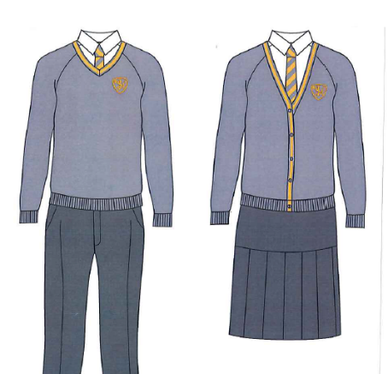
JUNIORS

Girls’ Uniform List
- Grey pinafore dress, skirt or smart, grey tailored trousers (not leggings)
- White blouse
- Grey sweater or cardigan with school crest
- Grey/gold tie
- White ankle or knee-length socks
- Plain black or grey tights, for winter wear
- Black shoes (not boots or trainers of any type)
- Yellow and white check or striped dress for summer wear
- Grey book bag with school crest

Boys’ Uniform List
- Grey tailored trousers (short or long length)
- White shirt
- Grey sweater with school crest
- Grey/gold tie
- Grey socks
- Black shoes (not boots or trainers of any type)

PE Kit
- House colour T-shirt with school crest
- Black shorts
- White socks
- Black plimsolls
- Black trainers for outdoor PE (optional)
- Black hoodie with school crest (no other logos) or plain black hoodie and plain black tracksuit bottoms can be worn to school on PE days

INFANTS

Uniform List

- Yellow polo t-shirt
- Grey cardigan/jumper with school crest
- Grey trousers, shorts or skirt
- Plain grey/black tights for winter weather
- Black shoes (not boots or trainers of any type)
- Yellow and white check or striped dress for summer wear

PE Kit
- White T-shirt
- Black shorts
- White socks
- Black plimsolls
- Black trainers for outdoor PE (optional)
- Black hoodie with school crest (no other logos) or plain black hoodie and plain black tracksuit bottoms can be worn to school on PE days

Stud earrings only, which need to be removed for PE days.

You can order our branded uniform from Price & Buckland here: UK’s Leading School Uniform Supplier - Price & Buckland (price-buckland.co.uk)



