Attendance Policy
St Joseph’s Junior School

Date Agreed: Nov 2025 Review Date: Nov 2026

Revision No. | Date Issued | Prepared  By | Approved | Comments
4 | May 2022 | L Hardy | Trust Board
5 | November 2024 | L Hardy | LGB
6 | Nov 2025 | N Metcalfe | LGB

Type of Policy | Tick
DCAT Statutory Policy
DCAT Non-statutory Policy
DCAT Model Optional Policy
Academy Policy

Contents
- Aims
- Legislation and guidance
- School procedures
- Authorised and unauthorised absence
- Strategies for promoting attendance
- Attendance monitoring
- Roles and responsibilities
- Monitoring arrangements
- Links with other policies
Appendix 1: attendance codes .

Together growing in learning, knowledge, life skills and love

‘Love one another as I have loved you. John 13:34-35

1. Aims
Within St Joseph’s vision, the academy aims to meet its obligations with regards to academy attendance by:
- Promoting good attendance and reducing absence, including persistent absence
- Ensuring every pupil has access to full-time education to which they are entitled
- Acting early to address patterns of absence
We will also support parents to perform their legal duty to ensure their children of compulsory school age attend regularly, and will promote and support punctuality in attending lessons.

2. Legislation and guidance
This policy meets the requirements of the school attendance guidance from the Department for Education (DfE), and refers to the DfE’s statutory guidance on school attendance parental responsibility measures. These documents are drawn from the following legislation setting out the legal powers and duties that govern school attendance:
- The Education Act 1996
- The Education Act 2002
- The Education and Inspections Act 2006
- The Education (Pupil Registration) (England) Regulations 2006
- The Education (Pupil Registration) (England) (Amendment) Regulations 2010 • The Education (Pupil Registration) (England) (Amendment) Regulations 2011
- The Education (Pupil Registration) (England) (Amendment) Regulations 2013
- The Education (Pupil Registration) (England) (Amendment) Regulations 2016
- The Education (Penalty Notices) (England) (Amendment) Regulations 2013
This policy also refers to the DfE’s guidance on the school census, which explains the persistent absence threshold.

This policy complies with DCAT’s Funding Agreement and Articles of Association.

3. School procedures
3.1 Attendance register
By law, St Joseph’s is required to keep an attendance register, and all pupils must be placed on this register.
The attendance register will be taken at the start of the first session of each school day and once during the second session. It will mark whether every pupil is:
- Present
- Attending an approved off-site educational activity
- Absent
- Unable to attend due to exceptional circumstances

Any amendment to the attendance register will include:
- The amended entry
- The reason for the amendment
- The date on which the amendment was made
- The name and position of the person who made the amendment

See appendix 1 for the DfE attendance codes.
Every entry in the attendance register will be preserved for 3 years after the date on which the entry was made.
Pupils must arrive in school by 8.40am on each school day.
The register for the first session will be taken at 8.45am. The register for the second session will be taken at 1pm.

3.2 Unplanned absence
Parents must notify the school on the first day of an unplanned absence – for example, if their child is unable to attend due to ill health – by 9.15am or as soon as practically possible (see also section 6).
This can be done by contacting the school on 01243 783709 and selecting option 1 where you will be able to leave a message.

Absence due to illness will be authorised unless the school has a genuine concern about the authenticity of the illness.
If the authenticity of the illness is in doubt, the school may ask parents to provide medical evidence, such as a doctor’s note, prescription, appointment card or other appropriate form of evidence. We will not ask for medical evidence unnecessarily. If the school is not satisfied about the authenticity of the illness, the absence will be recorded as unauthorised and parents will be notified of this in advance.

3.3 Medical or dental appointments
Missing registration for a medical or dental appointment is counted as an authorised absence; advance notice is required for authorising these absences and proof of the appointment will be required. However, we encourage parents to make medical and dental appointments out of school hours where possible. Where this is not possible, the pupil should be out of school for the minimum amount of time necessary and be in school before the appointment and return to school after the appointment.
This can be done by contacting the school on 01243 783709 and selecting option 1 where you will be able to leave a message.
Applications for other types of absence in term time must be requested by completing a request for absence form. Information relating to whether the school can authorise such absences can be found in section 4.

3.4 Lateness and punctuality
A pupil who arrives late but before the register has closed will be marked as late, using the appropriate code.
A pupil who arrives after the register has closed will be marked as absent, using the appropriate unauthorised code.

3.5 Following up absence
The school will follow up any absences to ascertain the reason, ensure proper safeguarding action is taken where necessary, identify whether the absence is approved or not and identify the correct attendance code to use.

3.6 Reporting to parents
St Joseph’s will report to parents on their child’s attendance record annually in the written end-of-year report.

4. Authorised and unauthorised absence
4.1 Granting approval for term-time absence
Headteachers may not grant any leave of absence to pupils during term time unless they consider there to be 'exceptional circumstances' and only for a very limited length of time. The request for absence must be on a request for absence form and sent to the school office at office@stjosephscejunior.school
Examples of any exceptional circumstances where leave may be granted during term time are as follows:
- If a parent is service personnel and is returning from a tour of duty abroad where it is evidenced the individual will not be in receipt of any leave in the near future that coincides with school holidays.
- Where an absence from school is recommended by a health professional as part of a parent or child’s rehabilitation from a medical or emotional issue.
- The death or terminal illness of a close relative, only if Headteacher is satisfied that the circumstances are truly exceptional (max 2 days including day of
funeral);
- Out of school programmes such as music, arts or sport operating at a high standard of achievement. Documentary evidence of this event will be required.
- Religious observance – The Education Act 1996 S444(3) (c), states ‘’on any day exclusively set apart for religious observance by the religious body to which his/her parent belongs’’; (Maximum 2 days)
- To attend a wedding or funeral of a close relative if the Headteacher is satisfied that the circumstances are truly exceptional; Leave should only be authorised for this purpose when a Headteacher is satisfied that there is a persuasive reason for holding the wedding during term time and there WILL be an onus on parents to show clear evidence that this absence is absolutely an exceptional circumstance. In difficult family situations the Headteacher may use his/her discretion in granting leave and each case should be addressed on its individual merits, taking into account the overall welfare of the child. (max 2 days for a wedding)
Where there are exceptional and unforeseen circumstances that fall outside of the above, the Headteacher agrees to consult with the Local Governing Board prior to any authorisation being given to the parent.
Evidence would be required in each case.
The school considers each application for term-time absence individually, taking into account the specific facts, circumstances and relevant context behind the request. A leave of absence is granted entirely at the Headteacher’s discretion. Valid reasons for authorised absence include:
- Illness and medical/dental appointments – as explained in sections 3.2 and 3.3
- Religious observance – where the day is exclusively set apart for religious observance by the religious body to which the pupil’s parents belong. If necessary, the school will seek advice from the parents’ religious body to confirm whether the day is set apart
- Traveller pupils travelling for occupational purposes – this covers Roma, English and Welsh Gypsies, Irish and Scottish Travellers, Showmen (fairground people) and Circus people, Bargees (occupational boat dwellers) and New Travellers. Absence may be authorised only when a Traveller family is known to be travelling for occupational purposes and has agreed this with the school but it is not known whether the pupil is attending educational provision
If no contact is received from the parents by lunchtime on the 3rd day of absence, a home visit will be conducted by the school safeguarding team.
If after contacting parents a pupil’s absence continue to rise, we will consider involving the Pupil Entitlement Investigation Team.

The persistent absence threshold is 10%. If a pupil's individual overall absence rate is greater than or equal to 10%, the pupil will be classified as a persistent absentee.
Pupil-level absence data is collected each term and published at national and local authority level through the DfE's school absence national statistics releases. The underlying school-level absence data is published alongside the national statistics. We compare our attendance data to the national average, and share this with governors.
Attendance is recorded on the school’s management systems called Arbor. Analysis and monitoring of the attendance data is undertaken using this system.
- Roles and responsibilities
  - The governing board
The governing board is responsible for monitoring attendance figures for the whole school on at least a termly basis. It also holds the headteacher to account for the implementation of this policy.
  - The headteacher
The headteacher is responsible for ensuring this policy is implemented consistently across the school, and for monitoring school-level absence data and reporting it to governors. The headteacher also supports other staff in monitoring the attendance of individual pupils and issues fixed-penalty notices, where necessary.
  - The attendance officer
The attendance officer:
    - Monitors attendance data at the school and individual pupil level
    - Reports concerns about attendance to the headteacher
    - Works with the Pupil Entitlement Team to tackle persistent absence
    - Arranges calls and meetings with parents to discuss attendance issues
    - Advises the headteacher when to refer to the PEI to issue fixed-penalty notices

  - Class Teachers
Class teachers are responsible for recording attendance on a daily basis and submitting this information to the school office.
  - Office staff
Office staff are expected to take calls from parents about absence and record it on the school system.
Office staff add this information on the school system, amending the code used where necessary.

7. Monitoring arrangements

This policy will be reviewed annually by DCAT and Headteacher. At every review, the policy will be shared with the local governing body, LGB.

8. Links with other policies
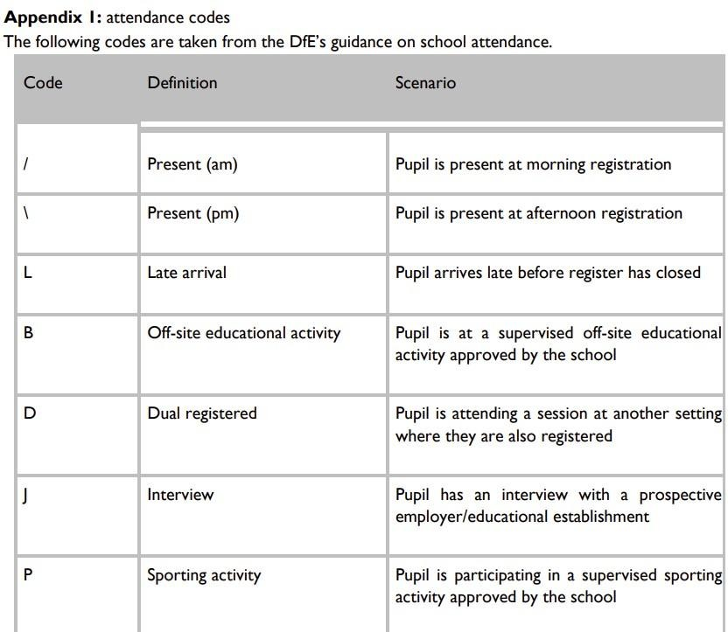
This policy is linked to our child protection and safeguarding policy.



