
St Joseph’s Nursery, Infant & CE Junior
Schools
Orchard Street
Chichester
West Sussex
PO19 1DQ
Tel: 01243 783709
Email: office@stjosephscejunior.school office@stjosephsinfant.school
Website: www.stjosephscejunior.school www.stjosephsinfant.school

Executive Headteacher: Mrs Nicky Metcalfe BA Ed (Hons) NPQH
Head of School: Mr Gareth Lehmann BA Ed (Hons)
____________________________________________________________________

24th April 2026

Dear Parents and Carers,

We are writing to share the news that, following a successful period supporting both the Infant and Junior Schools, Mrs Metcalfe will be appointed as the school’s Executive Headteacher from September and beyond.

We are delighted that her calm and considerate leadership is continuing to help pupils and staff develop and learn well. Her knowledge and experience as a Headteacher in Chichester are also a great strength for the school.

To support this next phase, and to ensure continuity and strength in leadership, Mrs Hardy will provide additional capacity and support as Executive Director next year, sharing her considerable experience and expertise.

On behalf of the Local Governing Body and the Trust, thank you for your continued support.

Yours faithfully
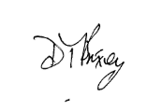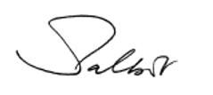

David Brixey (Chair of governors) Mark Talbot (CEO of DCAT)

